

Database fundementals II assignment



Ariel Rosenfeld

710567

Contents

Question 1 2

Question 2 3

LGBRAND 3

LGCUSTOMER 4

LGDEPARTMENT 4

LGEMPLOYEE 5

LGINVOICE 5

LGLINE 6

LGPRODUCT 7

LGSALARY_HISTORY 7

LGSUPPLIES 8

LGVENDOR 9

Question 3 10

Question 4 10

Question 5 10

Question 6 11

Question 7 11

Question 8 11

# Question 1

The Department Employs Employees.

Employees Manages The Department.

Employees Have Salaries.

Employees Completes Invoices.

Products Appear on Lines.

Customers Places Invoices.

Brands Includes Products.

Products Provided By Supplies.

Vendors Provides Supplies.

# Question 2

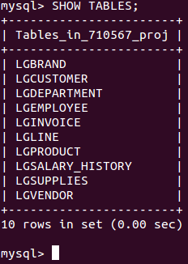

## LGBRAND

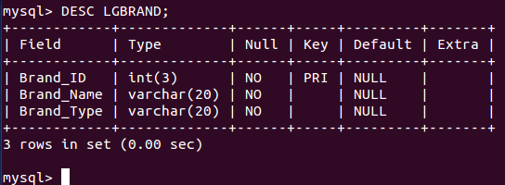

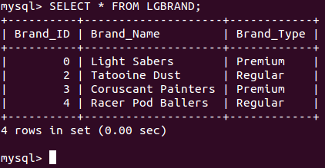

## LGCUSTOMER

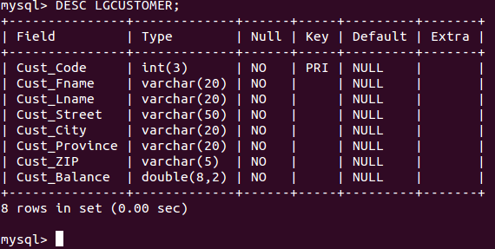

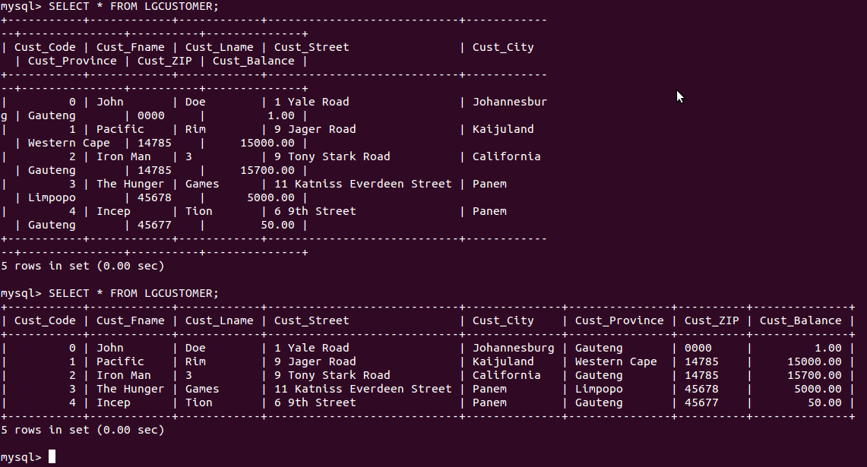

## LGDEPARTMENT

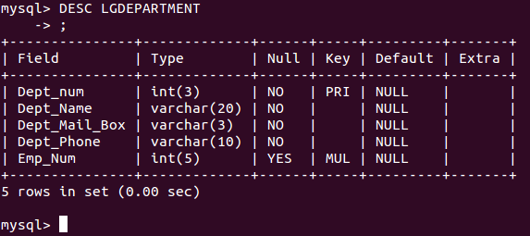

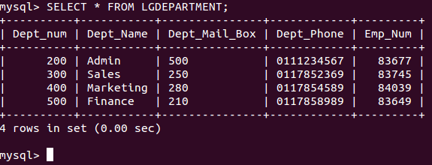

## LGEMPLOYEE

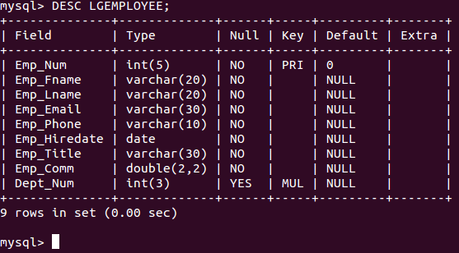

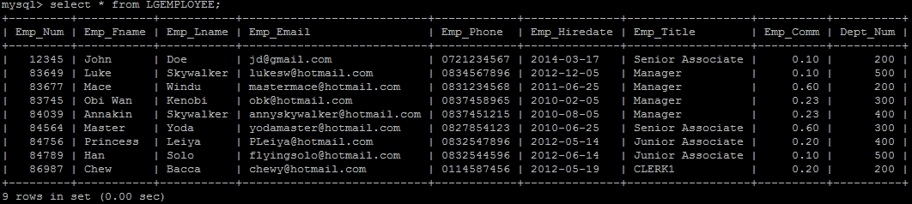

## LGINVOICE

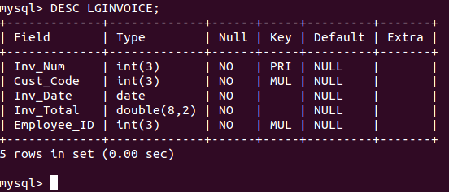

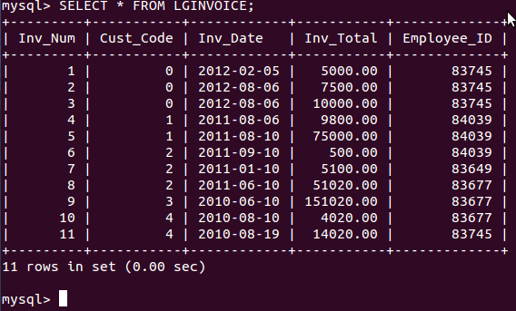

## LGLINE

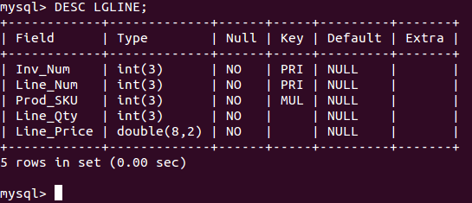

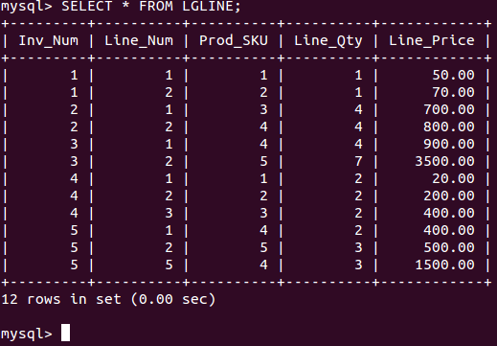

## LGPRODUCT

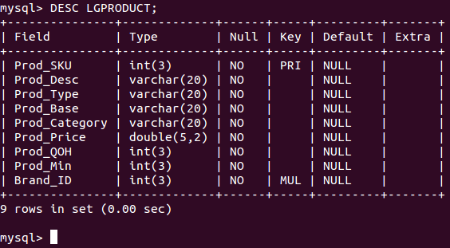

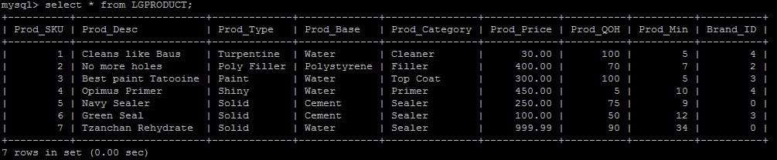

## LGSALARY_HISTORY

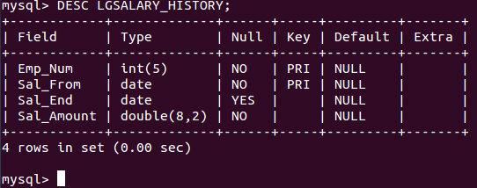

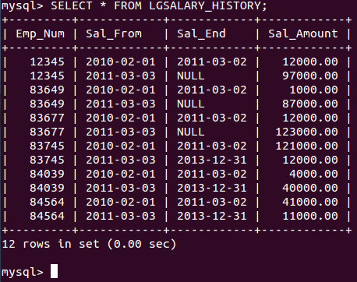

## LGSUPPLIES

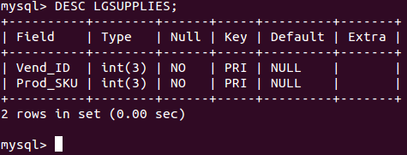

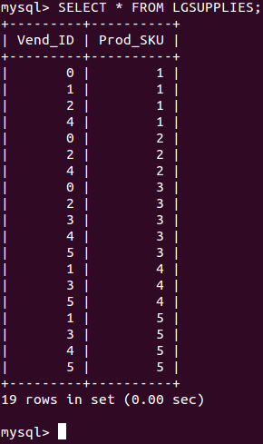

## LGVENDOR

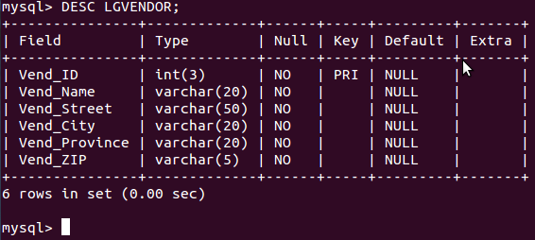

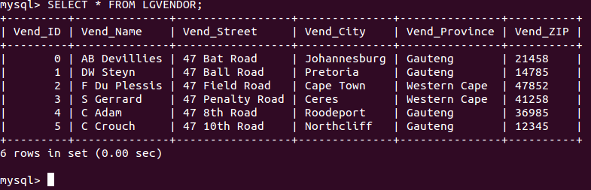

# Question 3

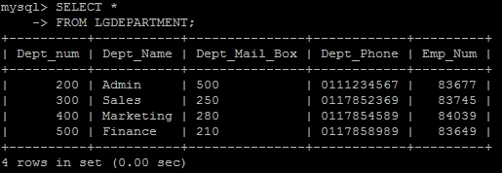

Selects all columns from table LGDEPARTMENT.

# Question 4

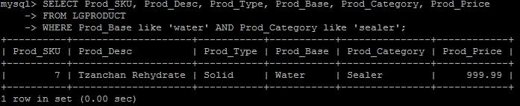

Selects columns Prod_SKU, Prod_Desc, Prod_Type, Prod_Base, Prod_Category and Prod_Price from table LGPRODUCT where Prod_Base is water (not case sensitive) and Prod_Category is sealer (not case sensitive).

# Question 5

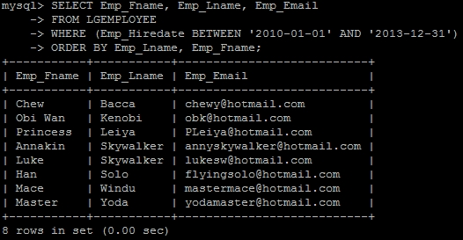

Selects columns Emp_Fname, Emp_Lname, Emp_Email from table LGEMPLOYEE where Emp_Hiredate is between 2010-01-01 and 2013-12-31. Sorted by Emp_Lname then Emp_Fname.

# Question 6

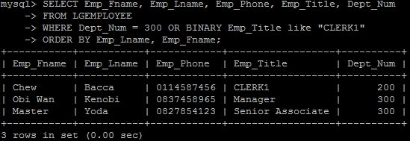

Selects columns Emp_Fname, Emp_Lname, Emp_Phone, Emp_Title, Dept_Num from table LGEMPLOYEE where Dept_Num is 300 or where the Emp_Title is CLERK1 (case sensitive). Sorted by Emp_Lname then Emp_Fname.

# Question 7

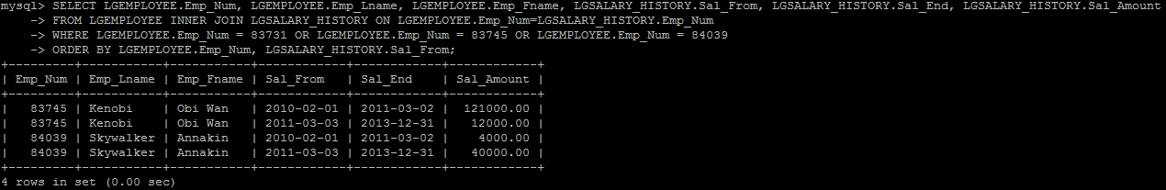

Selects Emp_Num, Emp_Lname, Emp_Fname from table LGEMPLOYEE and Sal_From, Sal_End, Sal_Amount from table LGSALARY_HISTORY where Emp_Num us 83731, 83745 or 84039. LGEMPLOYEE and LGSALARY_HISTORY are joined by the key Emp_Num. Sorted by Emp_Num then Sal_From.

# Question 8

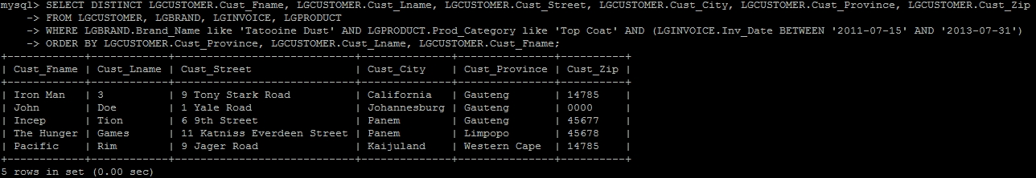

Selects (without repeated records) columns Cust_Fname, Cust_Lname, Cust_Street, Cust_City, Cust_Province, Cust_Zip from table LGCUSTOMER where Brand_Name (from table LGBRAND) is Tatooine Dust, Prod_Category (from table LGPRODUCT) is top coat and Inv_Date (from table LGINVOICE) is between 2011-07-15 and 2013-07-31. Sorted by Cust_Province then Cust_Lname then Cust_Fname.